**INSTRUCTIONS – WEEK 5 (April 14 – April 17)**

1. **MY HOME**

**Učb. 57** – klikni na drugi zvočnik ob nalogi 1, poslušaj in pokaži na prostore ali opremo, ki jih slišiš.

**What's your favourite room?**

Nariši sliko najljubšega prostora v tvojem domu in v njem označi čim več pohištva in opreme. Lahko tudi izdelaš plakat, na katerega pohištvo nalepiš – izrežeš ga iz reklam – in poimenuješ v angleščini. Pomagaj si s sliko v **UČB. str. 57**, kjer najdeš veliko besed.

Zdaj pa sliko tudi opiši.

*Npr****.: My favourite room is the*** *kitchen.* ***There is a*** *cooker in the kitchen. There is a sink.* ***There are three*** *cupboards in the kitchen. I make lunch in the kitchen. I really like my kitchen.*

O sliki zapiši vsaj 6 stavkov.

Zdaj v zvezek prepiši še 5 novih besed za pohištvo in jih prevedi v angleščino.

1. **REVISION – FAMILY MEMBERS (ponovimo – družinski člani)**

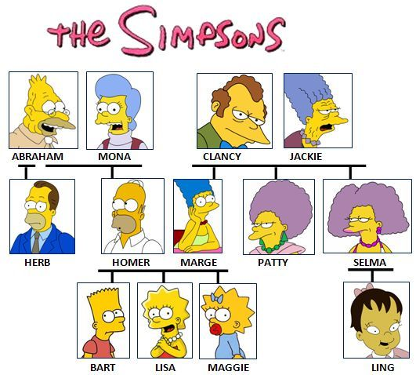

V zvezek napiši, kako so si Simpsonovi

v sorodu.

Npr.: Selma is Ling's mother.

Jackie is Ling's __________________.

Maggie is Lisa's _________________.

Bart, Lisa and Maggie are Homer and

Marge's _____________.

Bart is Ling's _________________.

Abraham is Lisa's _____________.

Patty is Bart's _________________.

Lisa is a teenager but Maggie is a _______________.

Homer and Marge are Bart's ________________.

**\*\*\* Bart's = Bartov, Maggie's = Maggiejin, Lisa's = Lisin …**

Have a good week!  
Your English teacher [](https://www.google.com/url?sa=i&url=https://www.pinterest.com/pin/309622543128563499/&psig=AOvVaw1d7izvxcA6gweLmTzgXd8j&ust=1584985040727000&source=images&cd=vfe&ved=0CAIQjRxqFwoTCNCF58TPrugCFQAAAAAdAAAAABAd)